
PROCONF
A Conference Management System for Research Development
A Research Development Project - Authors, Reviewer, Conferences Chair, and the thousands of others from over 100 countries explore PROCONF to power their conferences, workshops, symposia, journals, books, grants, and competitions.

Software as a Service (SaaS) Document

Agreement for
<Conference/ Journal /Event Name>
PROCONF  A Conference Management System for Research Development | 
Phone: +17202727236 (USA), +8801827593387 (Bangladesh)
Email: info@proconf.org

Summary:
PROCONF for < your conference short name > Agreement
Date | Service Performed By | Services Performed For
< date of agreement> | PROCONF Team | < Conference Chairperson/ Most Important Person Name >  < Organization Name >  < Persons Phone>  < persons Email>

Agreement Summary
Fill up the Forms
Agreement Organization Name | <university/group of university name>
Agreement Valid From | <date>
Agreement valid to | <date>

Fill up the Forms (Office Use Only)
Agreement License No
Authorized By
Authorized Date | <date>
Effective Application From | <date>

Authorized Signature (Office Use Only)  PROCONF Team | Organizer authorized Signature & Seal (Conference Chair)  < Person Name >  < Organization Name >  < Persons Phone>  <persons Email>  <application>

Conference/Workshop/Journal Summary
Fill up the Forms
Name of the event (Short Form) | < ICEEICT 2021 >
Name of the event (full Form) | < International Conference on Electrical Engineering and Information & Communication Technology 2021 >
Event Date | < December 07-09, 2021 >
Event Venue | < location full address >
Event Country | < Bangladesh>
Event Organizer | < University name >
Event Submission Link ** | Proconf.org/conferences/<iceeict-2021>/
* Example: proconf.org/conferences/ieee-r10-htc-2021/
* Example: proconf.org/conferences/journal/suj-2021/
*** Important: Please Attach conference/ workshop/ journal Banner (See Example: http://proconf.org/conferences/) –
< attach banner with the email > or <image link>

Organizer Summary (For Contact Purpose)
The personal information which we put into conference support in submission link.
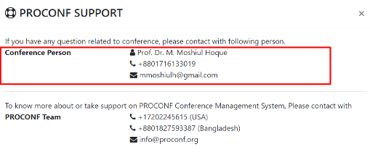
Fill up the Forms
Name of the Person
Person Affiliation
Person Organization
Person Phone
Person Email
Persons Other Information
Other Information you want to write -

Extra Person Information
We, the PROCONF team need at least 3 names, emails, and conference positions to communicate with you. We will cc all of them when we will send an email to one of you for conference communication.
Serial | Person Name | Email | Conference Position
1 | < Reza > | < reza@gmail.com > | Secretary
2
3
 | Add By yourself …

Pricing:
PROCONF is a research development project(non-profit). But for organizational development, we took donations/ support from those conferences that can support us.
Note that, we will not give PROCONF as full free service.
Your support will be used for future PROCONF development for future conferences.
Email us at info@proconf.org if you have any questions.
Packages:
- Basic – No Star – [ $1 for each submission]
- Professional – 2 Stars – [ $2 for each submission]
- Enterprise – 3 Stars – [ $3 for each submission]
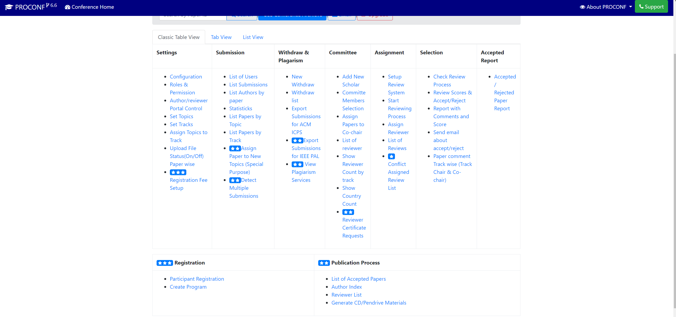

*As PROCONF helps to organize your conference and enhance research development, Conference authority should pay based on their submission no. We believe Conference/Research is not related to money. We use your payment as a maintenance charge of PROCONF.

We also encourage you to use “POWERED BY PROCONF” on the conference website.

Contact Information
To know more about or take support on PROCONF Conference Management System, please contact with
PROCONF Team
+17202727236 (USA)
+8801827593387 (Bangladesh)
info@proconf.org

Final Authorization
IN WITNESS WHEREOF, the parties hereto have caused this Software as a Service (SAAS) document to be effective as of the day, month, and year written above.

Authorized Signature (Office Use Only)  PROCONF Team | Contact User Signature & Seal (Technical Secretary)  < Person Name >  < Organization Name >  < Persons Phone>  <persons Email>  <application>

Our terms and conditions
These terms and conditions are divided into the following parts:
- a disclaimer of liability.
- terms and conditions governing the use of this application.
- a license for our free legal documents.
- general and interpretive provisions.
By using our application, you accept these terms and conditions in full. If you disagree with these terms and conditions or any part of these terms and conditions, you must not use our application. If you register with our application or buy any product or service from our application, we will ask you to expressly agree to these terms and conditions.
(A) General disclaimer
Legal information
Much of the legal information on this application consists of summaries of complex legal issues. Legal and factual details and nuances are inevitably omitted from such summaries. Circumstances often radically affect the law that applies, and the way that the law applies.
You should therefore never apply the legal information to your situation without conducting additional research or engaging a lawyer. Nor should you assume that all the relevant legal material is included in our application. Most of the legal information on this application relates to the laws of Bangladesh. However, this is not always the case. Do not assume that any item of legal information relates to any particular jurisdiction.
For all these reasons, you must not rely upon any information on this application, and we recommend that you take professional legal advice before embarking upon any course of action (or omitting to take any action) that has or may have legal implications.
(B) Terms and conditions of use
Unless otherwise stated, we or our licensors own the intellectual property rights in the application and material on the application. Subject to the license below, all these intellectual property rights are reserved.
Access to certain areas of our application is restricted. We reserve the right to restrict access to other areas of our application, or indeed our whole application, at our discretion. If we provide you with or you generate a password to enable you to access restricted areas of our application or other content or services, you must ensure that that password is kept confidential. You must notify us in writing immediately if you become aware of any unauthorized use of your account or password. You are responsible for any activity on our application arising out of any failure to keep your password confidential and may be held liable for any losses arising out of such a failure. You must not use any other person's user ID and password to access our application. We may disable your account on the application at our sole discretion without notice or explanation.
(D) Charges, payments, and credits
The charges shall be as specified on our application from time to time. We may vary the charges in our sole discretion at any time, by posting the varied charges on the application. If the member does not wish to pay charges at the new level, the member's sole remedy is to terminate the membership in accordance. All charges are stated exclusive of VAT unless the context requires otherwise.
(E) General and interpretative provisions
Subject to the first paragraph of Section A, these terms, and conditions, together with our privacy policy, constitute the entire agreement between you and us about your use of our application, and supersede all previous agreements in respect of your use of this application.

